6G5Z0024 – Assessed Exercise 2 (Trees)
This assessed exercise has 3 assessed tasks: Task A, Task B and Task C
Before commencing with the exercises, accept the latest assessed exercise from the GitHub classroom to create your new repo to work on this exercise.

Task A:
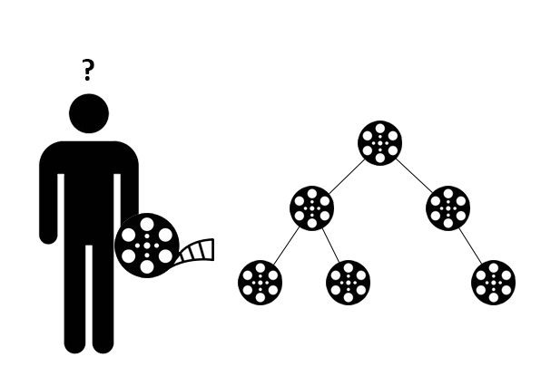
You have been asked to produce an application to assist with the storage and efficient lookup for film data as part of a preservation project. The application must be a Console Application with a Menu Driven Interface and must allow the user to interact with any newly implemented Binary Tree based data structures. All functionality implemented for the tree classes must be based on recursion. (Do not use any pre-existing solutions)
First, begin by implementing the Film class within the template code. For each film, we’ll assume that we’ll be storing the Title, the name of the credited Director and the Quantity of film reels that have been archived. When storing these objects into the tree, we’ll also assume that each film must have a unique title.
Following this, implement the required functionality within the Node, BinTree and BSTree classes, which must be used as part of the implemented menu interface by using the BSTree structure:
- Allow for new film objects to be Inserted into a BSTree.
- Display the contents of the tree via InOrder, PreOrder and PostOrder, which should be implemented into the BinTree class. Allow the user the choice of which of these to view via the interface.
- Obtain the current Height of the tree.
Hint: Example code for the above functionality can be found in the lab notes from week 5. Use these to help you implement the required functionality within your tree classes.
The height function should be node based, see Lecture 5A, slide 10 for guidance on this.

Task B:

Expand upon the BSTree class you have started to implement in the previous task to include the additional required functionality. This should also be used as part of the implemented menu interface:
- Display the current Count of entries that are present within the tree.
- Update an existing node that is currently present in the tree.

Hint: Consider basing your approach for implementing the update function on the InsertItem function. With the insert functionality, we should be using an approach that allows us to recursively navigate the tree by utilising the compare to method of whatever datatype is currently present within our tree. Based on this, we know when we need to go left if an item is smaller than the current node or right if the item is greater than the current node. So, what is the remaining use case?
You could base your approach for count off your height function, only now you will need to account for all nodes in the tree.

Task C:

Whilst BSTrees allow for quick efficient lookup, over time these structures can become unbalanced, undermining this otherwise time-effective functionality.
Implement the AVL Tree in your project that allows for nodes within the tree to be rotated as new data is inserted into the structure. You will also need to update your interface to now utilise the AVL Tree rather than BSTree to start using this functionality.
In conjunction to this, implement a function in AVLTree that allows for nodes to be Removed from the structure and for the interface to be updated to let a user use this.
Hint: To implement a AVL tree class, you will need to consider functionality that is able to evaluate the balance factor of nodes and to carry out any required rotations. See slides from week 6A to aid you with planning your approach to this.
For removal, review the three potential cases (Lecture 5B) to allow for node removal from the tree without losing any other required data. As removal will ultimately be changing the structure of your tree, this functionality should also account for any required rotations.

